How to work with the mongoDB?

MongoDB? : Unstructured and document based database where we can store data in the form of Documents.

To connect with mongoshell open cmd and execute:

Mongosh command it will connect with mongoDB Shell.

To check the available databases.

* Show databases;
* To create new DB: use db-name;
* To insert new record and to create new collection:
* Db.students.insert({id:1,name:”sonam”,email:[sonam@gmail.com](mailto:sonam@gmail.com),country:”india”})
* It will create new collection named students and insert one document inside the same.

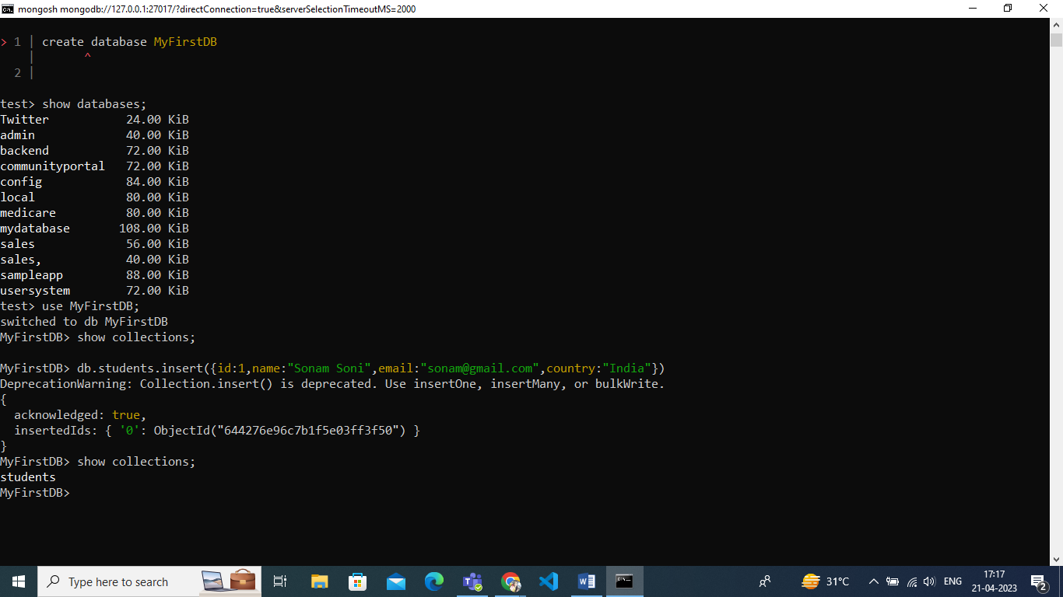

Insert Many Records.

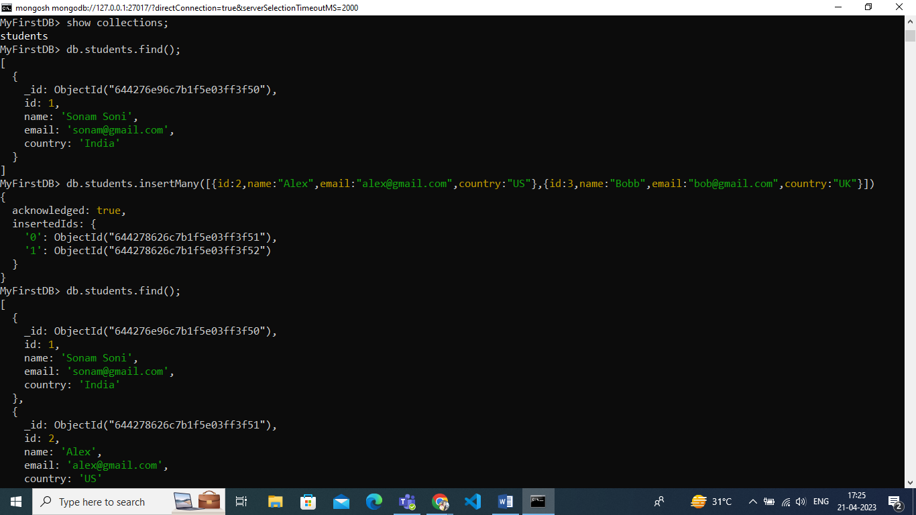

Fetch All Records (Documents)

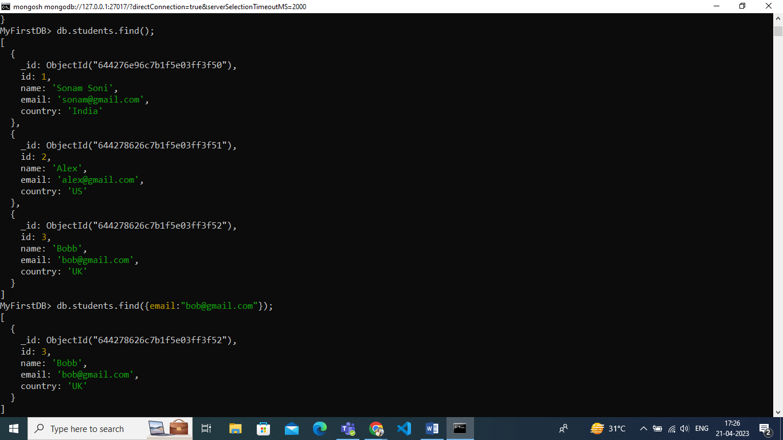

Fetch individual record based on conditions.

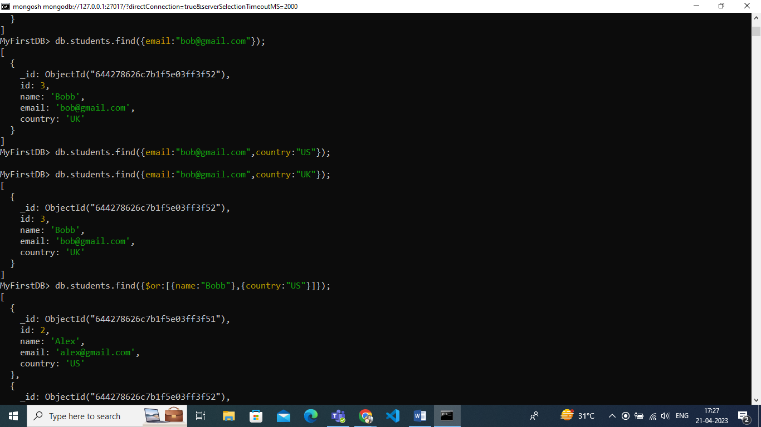

Using or operator.

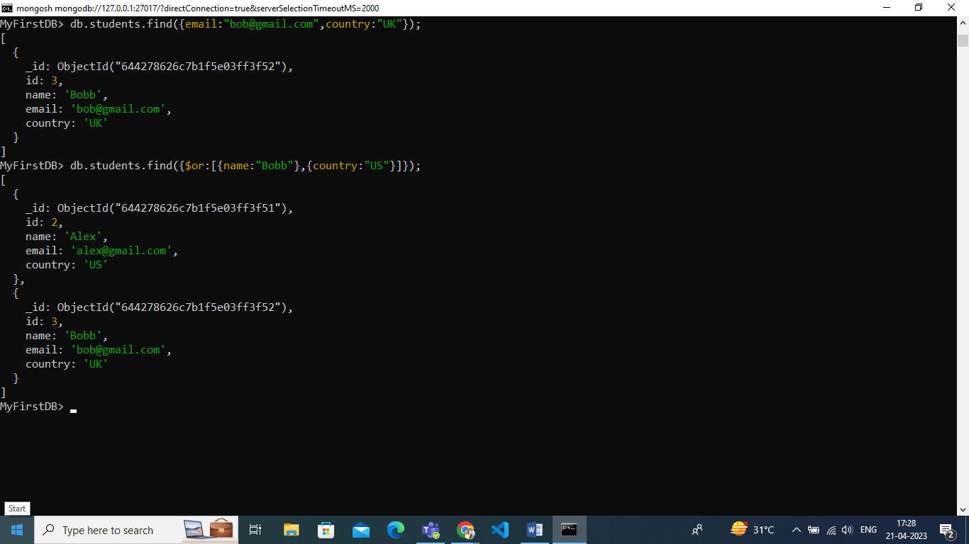

In operator in MongoDb

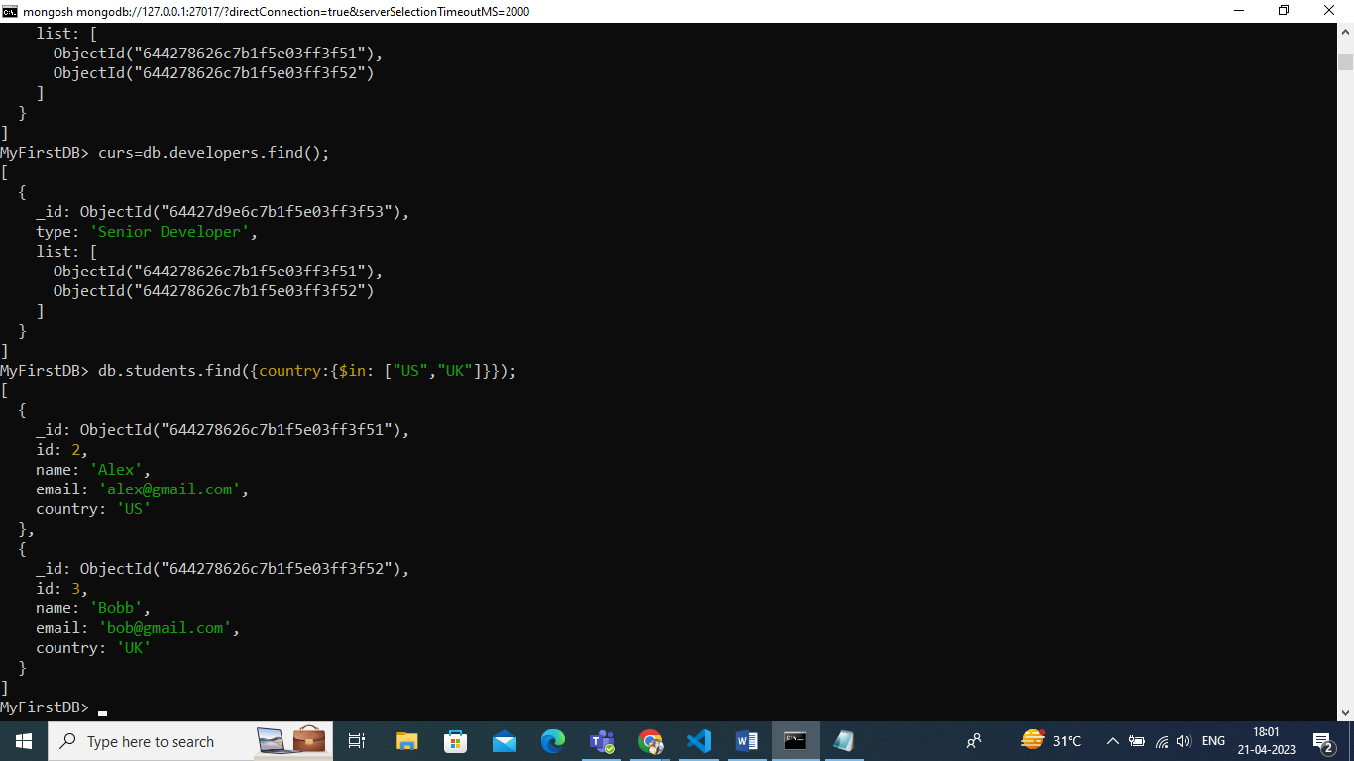

Let’s connect with Node application using mongodb and mongoose one by one.

const {MongoClient}= require('mongodb');

const url="mongodb://127.0.0.1:27017/"

const client= new MongoClient(url);

client.connect()

.then(()=>{console.log("Connected..!!!")})

.catch((err)=>{console.log('Failed to connect: ',err)})

const mongoose= require('mongoose');

const url="mongodb://127.0.0.1:27017/"

mongoose.connect(url)

.then(()=>{console.log("Connected..!!")})

.catch((err)=>{console.log("Failed to connect....!!",err)})